Pro Tour - Los Angeles Preview
Gary Wise
Some people say the Titanic was a great ship. This oversized dedication to excess and vice sails out of a harbor with Leo DiCaprio and Kate Winslet aboard for its first voyage, piloted by a vain captain looking to retire in a blaze of glory and steered from behind the scenes by owners whose first concern is public relations. The boat kisses an iceberg, the iceberg stays afloat, the dingy plummets into the ocean depths never to be seen for almost a century and almost everybody dies.
Call that a great ship? My idea of a great ship sees a retired warship/cruise liner whose sole purpose in my eyes is to house Magic tournaments. Every year gamers from around the globe will gather inside to play, compete and trade the Magical cards. Emotions will run high and the warmth of sunny California will consume all who visit.
My friends, such a ship exists. Her name...is Queen Mary.
In a week, Magic's finest will be gathering in Long Beach, California's best-known tourist trap for the sixth time, this time with more money at stake than ever before. With a $30K first prize, qualified players spanning the globe have been hard at work utilizing their neighboring players and local stores in the hopes of learning how to draft Invasion a little bit better than the next guy or, after New Orleans, the next girl (hey Michelle).
That said, this prognosticator has taken to heart the task of helping you fantasy Magic players and PT hopefuls out there that are trying to figure out just who is going to win this thing. Here there are my best guesses:

THE FAVORITES
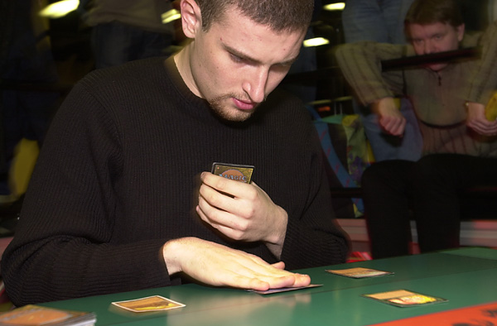
Jon Finkel - Big shocker right? Jon's been on an incredible streak ever since the Masters Series' existence was announced to the public. It's amazing what the almighty dollar can do. With wins at US Nats and Worlds as well as a Top 8 finish at Chicago and a 2nd place finish in Chicago Masters, Jon has shown that not only is he definitely the world's best player, but also he seems to know this format.
Chris Benafel - Chris' rep may be a bit shaky, but his results are anything but. Bursting onto the scene with last year's second place finish on the boat, Chris then followed that performance up with a 2nd place finish at US Nationals and a win in the Teams event at World Championships. Benafel has shown that he drafts Invasion as well as any, with his Win in Amsterdam, 2nd place finish in Dallas and 12th place finish in New Orleans showing remarkable consistency.
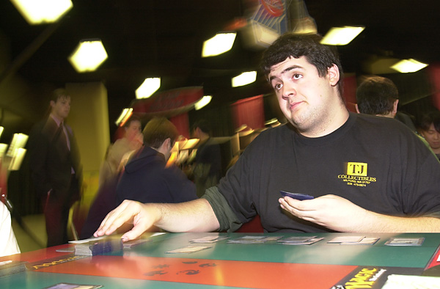
Baby Huey - Bill Jensen has been considered among the top 5 drafters in the world for some time now, but this may be the set that sees him truly hit his stride. An avid money drafter, Billy's most constant partners, Casey McCarrel, Brock Parker, Matt Linde and Ben Rubin all seem to agree that there's no one they'd rather have on their team. Billy's streak of 3-0 money draft records keeps stretching longer and longer. Capable of drafting any color combo well, Jensen will be hard to stop in LA.
Trevor Blackwell - Trevor proved that his victory in LA last year was no fluke with a 10th place finish in New York, but the San Francisco native seems to have quieted down. That said, Trevor finished 21st in New Orleans, and that because instead of showing up for the first draft in Day 2, he spent his morning with some friends he'd made the night before. The result of his missing the draft was three match losses, meaning at the end of the tournament, his record in rounds he actually played in was 6-0-1. Not too shabby.

POSSIBLE BREAKTHROUGHS
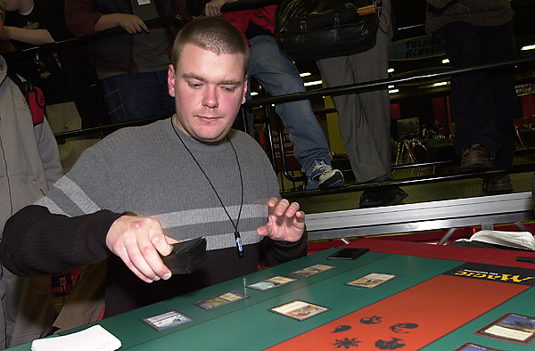
Sigurd Eskeland - Not quite Joe Scrub, Sigurd, whose lone PT win came in Constructed, was for a long time considered a Limited specialist. With Sigurd enjoying life with his new girlfriend, the big Viking has quietly been making his way onto IRC in order to get in as many drafts as possible. His confidence in his game is as high as I've ever seen it, so look for a strong finish.
Steve O'Mahoney-Schwartz - SteveO isn't exactly a rank amateur either, but he'd be the first to tell you that he hasn't been doing as well as he'd like since his win on the boat two years ago. With University cutting into his gaming time, you can hardly blame him, but Steve is considered by many to be the best Rochester drafter in the game, as evidenced by his finishes in LA4 (the last Rochester PT) and Mainz, where he finished 2nd to a seemingly possessed Matt Place. You don't want this man at your table.
Dustin Stern - I met Dustin in Dallas before he'd made Top 8 there or in New Orleans. With no PTs and 2 GPs to his credit, that Dustin has two Top 8 finishes is remarkable. Perhaps not as well known as the other players on this list, his making Top 8 in LA wouldn't surprise me too much.
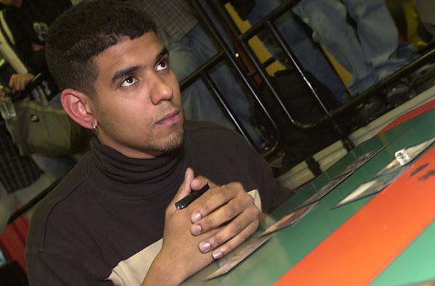
Dave Williams - Dave loves money drafting. It's just that simple. Day and night at PT or GP events, Williams will have cards in hand, trash talking away as he tries to pocket another $50. Williams, who has attended more GP's than anyone this side of Alex Shvartzman has seen his constant efforts pay dividends, with a Top 8 finish in the Chicago Masters being derailed despite his drafting what everyone seemed to think was the best deck at the table. Look for Williams to do well this weekend, whether in the big tourney or playing 3-on-3
So those are my picks. Of course, that doesn't mean regular top finishers like Ben Rubin, Kai Budde or Mike Turian won't do well, but these are the guys I expect to see at the top of the standings come Saturday afternoon. Good luck in your fantasy pools, and may the best drafter win.

